Use Case Designs What a System will do.

* Actor is the End User
  + Primary Actor is the user who initiates the action
  + Secondary Actors are only active participants.
* Use Case is the Task or Goal
* The Whole Thing is called a scenario.
* Use Case can have 2 views
  + Simple View
  + Use Case Tables with all details.
    - Use Case
    - Use Case Name
    - Description
    - Primary Actor
    - Trigger
    - Pre-Condition
    - Failed End condition
    - Action
    - Main Scenario
    - Action
    - Alternate Scenario
    - Successful Scenario
    - Notes & Open Issues
  + Include and Extends
    - Is-A = Extends
    - Has-A = Include
  + 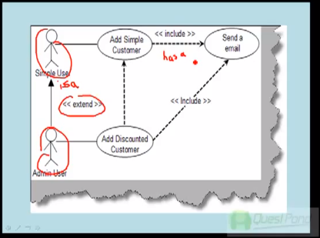

Sources

<http://www.youtube.com/watch?feature=fvwp&NR=1&v=Zk-580BqSNY>

Class Diagram

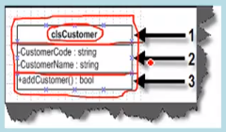

1. Class Name
2. Attributes
3. Methods

* Class is basically a prototype which helps create objects
* A Class represents a blueprint for program

How are the methods exposed to the world?

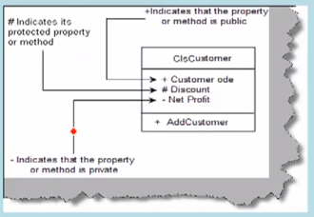

+ = Public property or method.  
# = Protected property or method.  
- = Private property or method.

Sources

<http://www.youtube.com/watch?NR=1&v=w2m-7YcHVck&feature=fvwp>

Object Diagrams

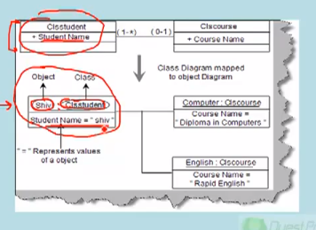

Classes represents show the static of the system.

Object diagram gives a diagram of the classes with data at any point in time.

Sources

<http://www.youtube.com/watch?feature=fvwp&NR=1&v=sljwzrlJrjw>

Sequence Diagram

Sequence Diagrams show the interaction between objects over a specified period of time

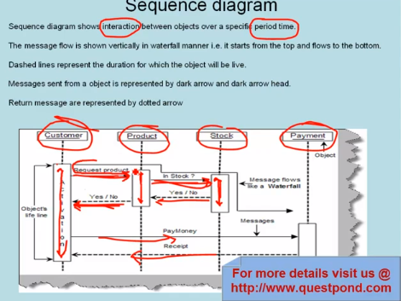

Messages in Sequence Diagrams

Four Kinds

1. Synchronous Messages
2. Asynchronous Messages
   1. 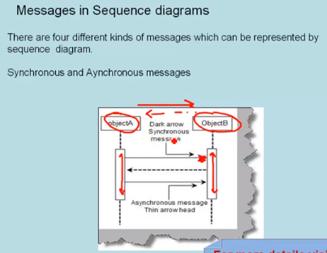
3. Recursive Messages
   1. 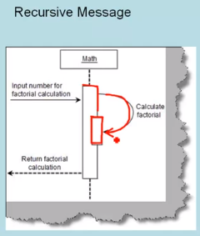
4. Message Constraints
   1. 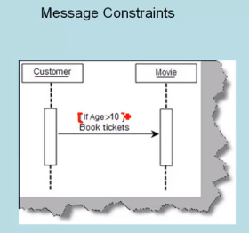

Sources

<http://www.youtube.com/watch?feature=fvwp&NR=1&v=4WDbte6cPa8>